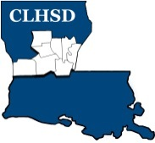
Central Louisiana Human Services District
Board Meeting Agenda
May 6, 2021

- Call to Order/Quorum
- Prayer/Pledge

- Read and Approve May 2021 Meeting Agenda
Solicit Public Comment Requests

- Approval of Minutes
April 2021 Board Meeting Minutes

- District Reports

  - Financial Report H1

  - ED Monthly Report H2

- Policy Reviews
Executive Limits
  - II. F. Emergency ED Succession with corresponding procedure - H3 -Shannon Thorn

- Board Business

- Board Development/Training– District Advisory Council
- Annual Ethics Training and completion of Tier 2.1 – Covering Calendar Year 2020 to be completed by May 15th
- Board Member Self-Assessment distributed

- Next Month
- Convene nominating committee
- Review Board Member Self -Assessment
- Prioritized Strategic Initiatives for Coming Year

- Questions/Comments As Solicited

- Announcements
- Next meeting is June 3, 2021
- Adjourn

